

**AIM:**

Write a program to implement time series data for import library, load data, Preprocessing and visualising.

**ALGORITHM:**

Step 1: Install required libraries (if not already installed).

Step 2: Import necessary libraries (pandas, numpy, matplotlib).

Step 3: Load oil prediction data, parse dates, and set 'date' as the index.

Step 4: Remove duplicate timestamps and fill missing values.

Step 5: Select the 'price_today' column.

Step 6: Remove outliers using the IQR method.

Step 7: Ensure daily data frequency.

Step 8: Resample to weekly average (optional, not used in the plot).

Step 9: Create a figure and plot daily price levels as a line graph.

Step 10: Set labels, title, and legend for the plot.

Step 11: Show the plot.

**CODE:**

import os

file_path = r"D:\Abdul\ex-2\Crude oil.csv"

if os.path.exists(file_path):

print("File exists!")

else:

print("File not found. Check the path.")

import pandas as pd

file_path = r"D:\Abdul\ex-2\Crude oil.csv"

# Read CSV without parsing dates

df = pd.read_csv(file_path)

# Print the first few rows and column names

print(df.head())

print("\nColumn names:", df.columns.tolist())

import pandas as pd

file_path = r"D:\Abdul\ex-2\Crude oil.csv"

# Read CSV with correct date parsing

df = pd.read_csv(file_path, parse_dates=['Date'])

# Set 'Date' as the index

df.set_index('Date', inplace=True)

print(df.head()) # Verify output

import pandas as pd

import matplotlib.pyplot as plt

import seaborn as sns

# Load dataset

file_path = r"D:\Abdul\ex-2\Crude oil.csv"

df = pd.read_csv(file_path, parse_dates=['Date'])

df.set_index('Date', inplace=True)

# Convert 'Close/Last' to numeric

df.rename(columns={'Close/Last': 'Close'}, inplace=True)

df['Close'] = pd.to_numeric(df['Close'], errors='coerce')

# 1️⃣ Line Chart - Price Trend Over Time

plt.figure(figsize=(12, 6))

plt.plot(df.index, df['Close'], label='Close Price', color='blue')

plt.xlabel("Date")

plt.ylabel("Close Price (USD)")

plt.title("Crude Oil Closing Price Trend")

plt.legend()

plt.grid()

plt.show()

# 2️⃣ Moving Average (50-day)

df['50_MA'] = df['Close'].rolling(window=50).mean()

plt.figure(figsize=(12, 6))

plt.plot(df.index, df['Close'], label='Close Price', color='gray', alpha=0.6)

plt.plot(df.index, df['50_MA'], label='50-Day MA', color='red')

plt.xlabel("Date")

plt.ylabel("Price (USD)")

plt.title("Crude Oil Price with 50-Day Moving Average")

plt.legend()

plt.grid()

plt.show()

# 3️⃣ Bar Chart - Trading Volume

plt.figure(figsize=(12, 6))

plt.bar(df.index, df['Volume'], color='purple', alpha=0.7)

plt.xlabel("Date")

plt.ylabel("Volume")

plt.title("Trading Volume Over Time")

plt.show()

# 4️⃣ High-Low Range (Shaded Area)

plt.figure(figsize=(12, 6))

plt.fill_between(df.index, df['Low'], df['High'], color='lightgray', alpha=0.5, label='High-Low Range')

plt.plot(df.index, df['Close'], label='Close Price', color='black')

plt.xlabel("Date")

plt.ylabel("Price (USD)")

plt.title("Crude Oil Price Range (High-Low)")

plt.legend()

plt.grid()

plt.show()

# 5️⃣ Box Plot - Price Distribution

plt.figure(figsize=(8, 6))

sns.boxplot(y=df['Close'], color='cyan')

plt.ylabel("Price (USD)")

plt.title("Crude Oil Price Distribution")

plt.grid()

plt.show()

**OUTPUT:**

**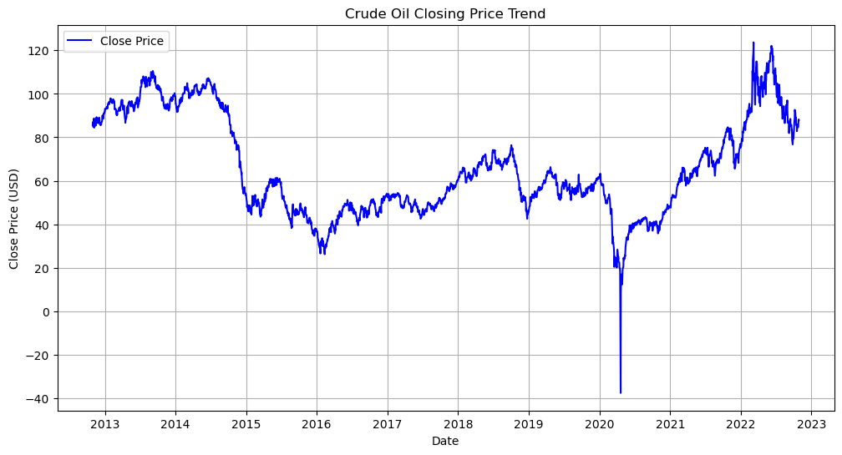  
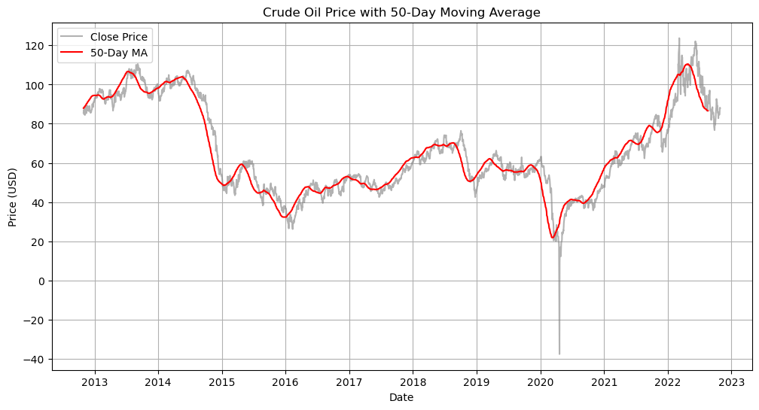**

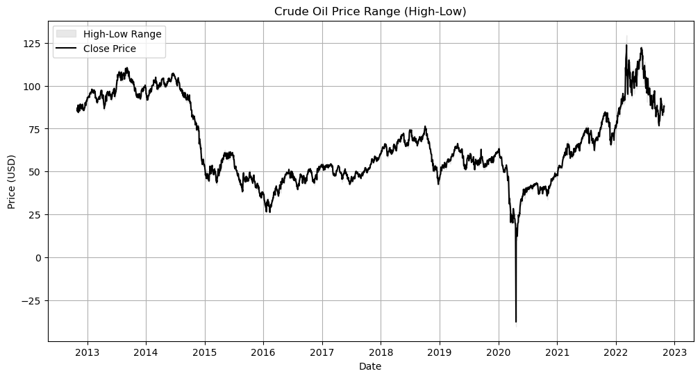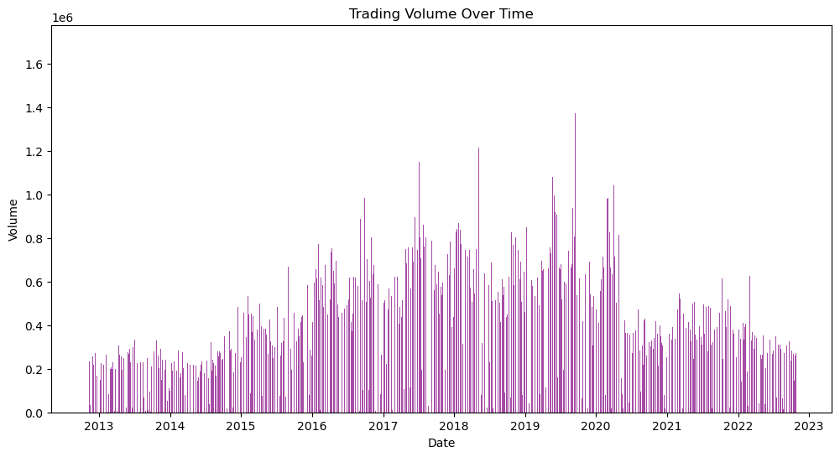

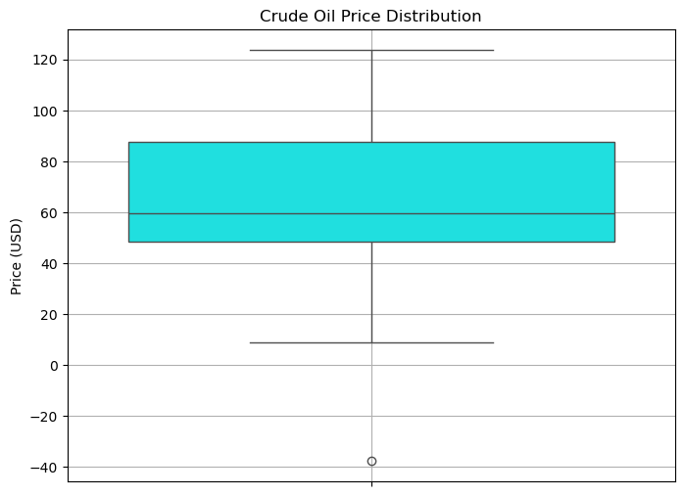

**RESULT:**

Thus, the program using the time series data implementation has been done successfully.